Star Type Classification / NASA Dataset

# Introduction

Stars aren’t just big orange balls of fire, there exist multiple kind of stars with many colours, size and temperature as it can be seen on the Figure 1.

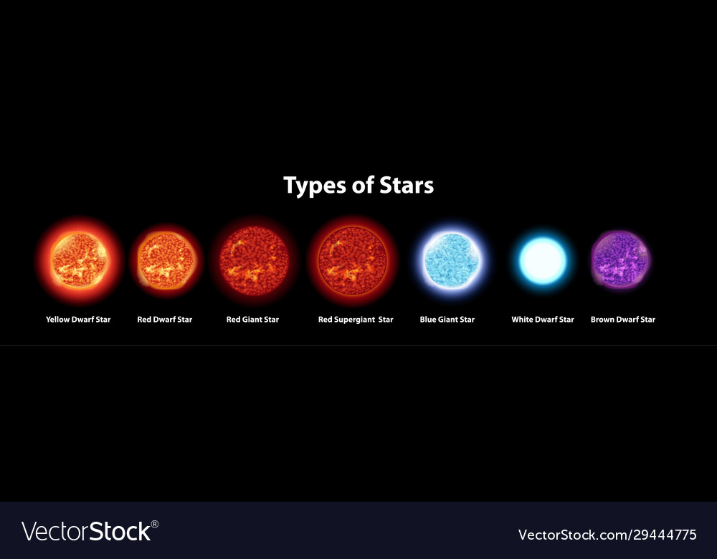

Figure 1. Types of stars

A Hertzsprung-Russell diagram is a scatter plot that can be used to show the relationship between various stars characteristics as shown on the Figure 2 and Figure 3.

Figure 2. Hertzsprung-Russell diagram 1

Figure 3. Hertzsprung-Russell diagram 2

# Data Exploration

The dataset is composed of 240 stars belonging to 6 different kind of stars such as :

* Red Dwarf (**0**)
* Brown Dwarf (**1**)
* White Dwarf (**2**)
* Main sequence (**3**)
* Super Giants (**4**)
* Hyper Giants (**5**)

And the 6 main features are :

* **Temperature** in Kelvin.
* **R☉**, the solar radius, a unit of distance used to express the size of stars in astronomy relative to the Sun.
* **L⊙**, the luminosity of a given star. Luminosity is an absolute measure of radiated electromagnetic power (light), in this case it’s used in the terms of the luminosity of the Sun.
* **Absolute Magnitude**, a measurement of the luminosity of a celestial object. An object's absolute magnitude is equal to the apparent magnitude that the object would have if it were viewed from exactly 32.6 light-years.
* The **colour** of the star.
* The **Spectral class** is a spectral classification based on spectral characteristic obtained via analyse of the electromagnetic radiation.

As we can see on the Figure 4, the distribution is homogeneous, there’s 40 stars of each type.

Figure 4. Numbers of stars per type

Figure 5. Boxplots per type for the Temperature

Figure 6. Boxplots per type for the Luminosity

Figure 7. Boxplots per type for the Solar Radius

Figure 8. Boxplots per type for the Absolute Magnitude

As we can see, it seems that temperature and absolute magnitude are the feature that separate the star type the most easily.

As shown on the Figure 9, a lot of the colours are written differently multiple times such as “Blue white” and “Blue-White”. After some pre-processing, we can see more clearly on the Figure 10 that most of the stars are Blue, Blue White or Red.

Figure 9. Coulours before changes

Figure 10. Coulours after changes

And finally, most of the stars are either of spectral class K, G or B.

Figure 11. Numbers of Stars per Spectral Class

Using a PCA to plot the data, a graph similar to an Hertzsprung-Russell diagram is obtained with brown and red dwarf near each other (0 and 1), the main sequence in the middle (3), the white dwarfs in the bottom (2) and the giants (4 and 5) at the top.

Figure 12. PCA showing the types of stars

Using another dimension reduction method, T-SNE, to plot the data, we can still see some similarities to the Hertzsprung-Russel diagram. The red and brown dwarf (0 and 1) are near each other again. Likewise for the giants (4 and 5). The main sequence (3) is still in the middle and the white dwarfs (2) are at the bottom.

Figure 13. T-SNE showing the types of stars

In our case, the PCA seems better to represent the data in two dimensions, since the representation is mostly a straight line with the T-SNE.

# Unsupervised learning (Kmeans, Hierarchical clustering)

# Supervised learning (KNN)

This dataset can be used to predict the type of start from the 6 features, a KNN can be used with k = 4 as shown on the Figure 14.

Figure 14. Accuracy rate for each K value

We can see on the confusion matrix (Table 1), that 1 red dwarf is misclassified as a brown dwarf. This is probably due to red and brown dwarf being similar (see Hertzsprung–Russell diagram) and 1 red dwarf is among brown dwarfs in both the PCA and T-SNE plots. The same phenomenon can be observed for the misclassified hyper giant which is similar to a super giant.

Table 1. KNN Confusion Matrix

Globally KNN gives some good results (Table 2) with an overall accuracy of 0.96 on a test set. With precision, recall and f1 score being high across the board.

Table 2. KNN Metrics

# Conclusion

# References

Data : <https://www.kaggle.com/brsdincer/star-type-classification>

<https://en.wikipedia.org/wiki/Absolute_magnitude>

<https://en.wikipedia.org/wiki/Luminosity>

<https://en.wikipedia.org/wiki/Solar_radius>

<https://cosmonova.org/different-types-stars-stellar-evolution/>